Jingmian Zhang

Algorithm 1 (ALG1)-java

1.Experience

For this program, the initial difficulty lies in the input procedure. Using a for loop to take a input with hasNextInt() as a condition will successfully take in integers and add them to the list, but will not terminate unless user enters some non-integers input. By just using scanner to take one line(nextLine()) and store it in a string, the problem is solved. Then the program proceeds to split the string into array of integers and store them in the list. For reversing the list, a linked-list structure is used. Linked list is constructed by consecutive nodes which point to the other except the last one, which points to null. Moreover, the first node is noted as head. Each node contains some data (integers in this case). To reverse the list, a for loop is used to traverse the list and modify the pointers between the nodes. Three steps are essential in this process, firstly, remember the originally next node of the current node. Then, disconnect the current node and the originally next node, and connect the current node to the previous node. Finally, proceed to modify the next node by moving the pointers to current and previous node by one node further. By finishing the assignment, I review and relearn some of the basics concepts of linked list data structure.

2.Test-run

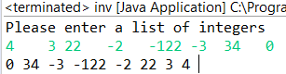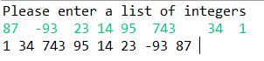

https://lh6.googleusercontent.com/AlaG6ZsNkvCTQZMns47KMThtKXD9K4riflJvCRq-PMBIwzRgIWduNGAZ8OhmMpVmBSXGzVDsA1T4TFHmNOEJ0fmKmpZUX5ArbrH-4GR9p0Ga3NYcltc7gzmpUUAigX_tOXYejsRPWiCd0q9Lcw